**Министерство науки и высшего образования Российской Федерации**

федеральное государственное автономное образовательное учреждение

высшего образования

**Национальный исследовательский университет ИТМО**

Факультет Систем Управления и Робототехники

Дисциплина: Основы Цифрового Производства

**Отчет**

по практической работе № 1

***Подготовка управляющей программы***

***для фрезерного станка с ЧПУ в***

***системе Fusion 360***

Студент: Евстигнеев Дмитрий  
Кулижников Евгений  
Виноградов Сергей

Группа: R33423

Преподаватель: Третьяков С.Д

Санкт-Петербург

2021 г.

1. 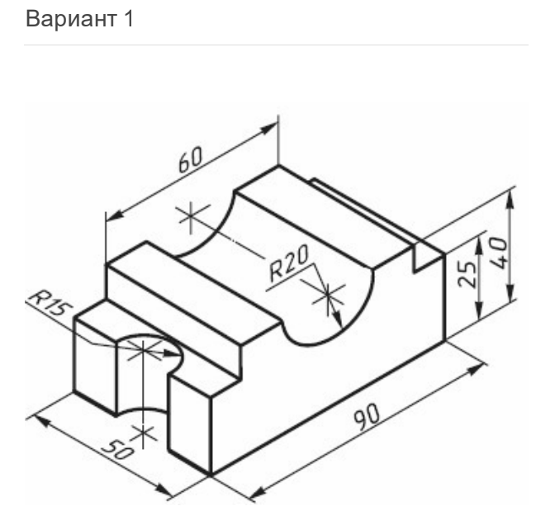**3D-модель**

**Был выбран первый вариант, так как по условию вариант определяется по табельному номеру ИСУ. Мы решили взять номер Виноградова С. (№1)**

**В итоге моделирования была получена модель *(рис.2-4)***

1. **Фрезерование поверхности *(рис.5)***

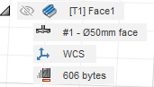

1. **Сверление отверстия R=15mm *(рис.6)***

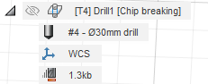 **Выбранные х-ти сверла видны на (рис.8)**

1. **Сверление отверстия R=20mm *(рис.7)***

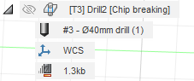 **Х-ти сверла иден. (рис.8), но диам. 40мм**

1. **Фрезерование контура *(рис. 9)***

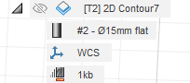

1. 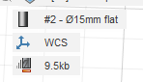**Фрезерование углуб. *(рис.10)***
2. **Постпроцессинг**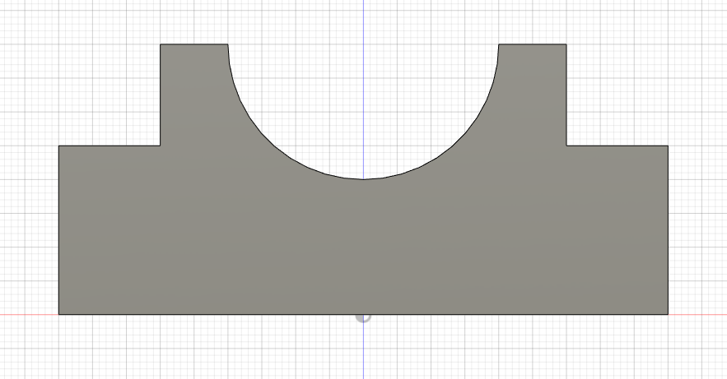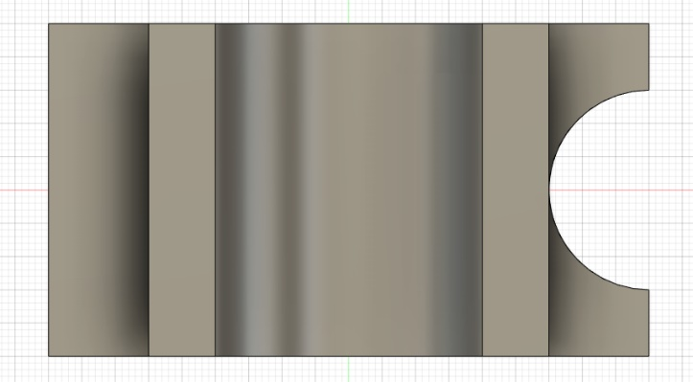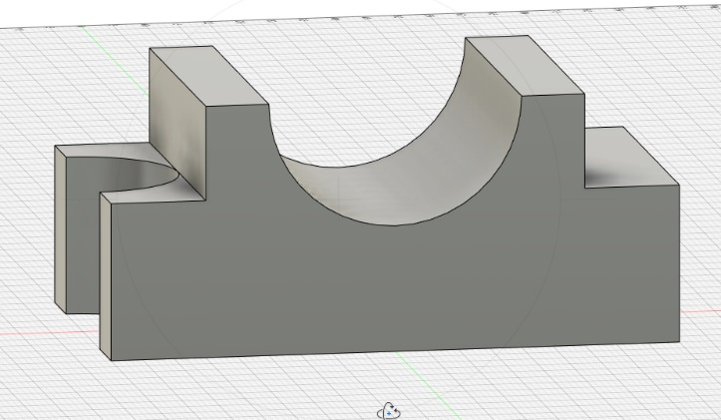

Рисунок 4. Главный вид

Рисунок 3. Вид сверху

Рисунок 2. Модель в Fusion 360

Рисунок 1. Заданный эскиз варианта 1

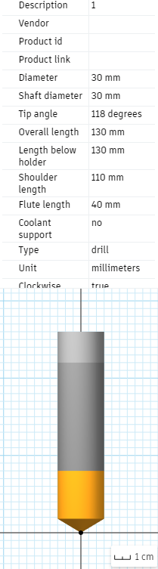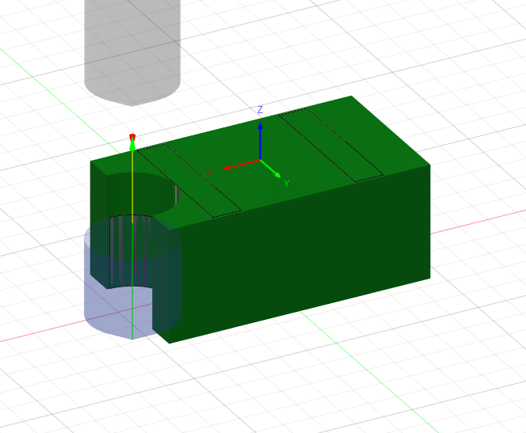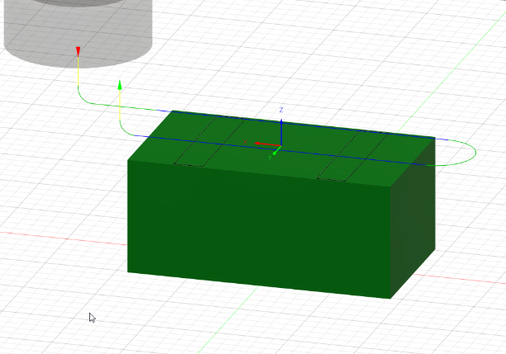

Рисунок 6. Сверление отверстия диам. 30мм

Рисунок 5. Фрезерование поверхности

*%*

*O01001*

*(Using high feed G1 F500. instead of G0.)*

*(T1 D=50. CR=0. - face mill)*

*(T2 D=15. CR=0. - flat end mill)*

*(T3 D=40. CR=0. TAPER=118deg - drill)*

*(T4 D=30. CR=0. TAPER=118deg - drill)*

*N10 G90 G94 G17*

*N15 G21*

*N20 G53 G0 Z0.*

*(Face1)*

*N25 T1 M6*

*N30 S955 M3*

*N35 G54*

*N40 M11*

*N45 G0 A0.*

*N50 M10*

*N55 M8*

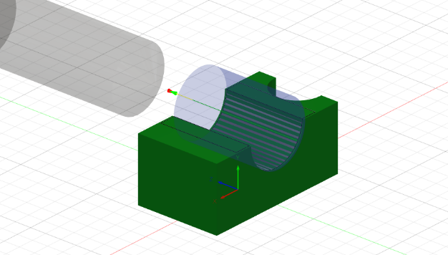*N60 G1 X78.5 Y-24.375 F500.*

Рисунок 8. Хар-ти сверла

*N65 G0 G43 Z15. H1*

*N70 T4*

*N75 G0 Z5.*

*N80 G1 Z4. F460.*

*N85 G18 G3 X73.5 Z-1. I-5. K0.*

*N90 G1 X51.*

*N95 X-51.*

*N100 G17 G2 Y1.775 I0. J13.075*

*N105 G1 X51.*

Рисунок 7. Свердление отвер. диам. 40мм

*N110 G18 G2 X56. Z4. I0. K5.*

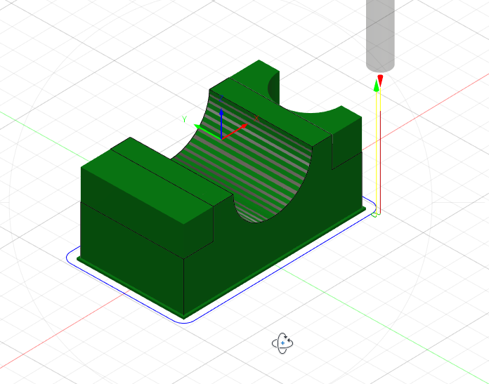*N115 G0 Z15.*

*N120 M9*

*N125 M5*

*N130 G53 G0 Z0.*

*(Drill1)*

*N135 M1*

*N140 T4 M6*

*N145 S5000 M3*

*N150 G54*

*N155 M11*

*N160 G0 A0.*

Рисунок 9. Фрез. контура

*N165 M10*

*N170 M8*

*N175 G17*

*N180 G1 X45. Y0. F500.*

*N185 G0 G43 Z15. H4*

*N190 T3*

*N195 G0 Z5.*

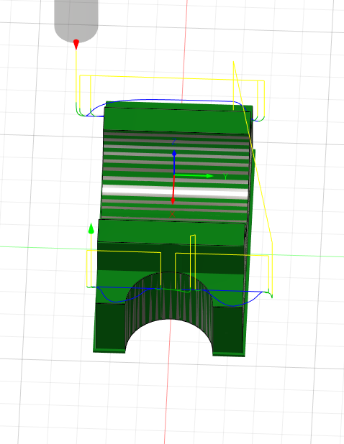*N200 G98 G73 X45. Y0. Z-52.013 R-11. Q7.5 F333.33*

*N205 G80*

*N210 G0 Z15.*

*N215 M9*

*N220 M5*

*N225 G53 G0 Z0.*

*(Drill2)*

*N230 M1*

*N235 T3 M6*

*N240 S5000 M3*

*N245 G54*

*N250 M11*

*N255 G0 A90.*

*N260 M10*

Рисунок 10. Фрез. угл

*N265 G1 X0. Y1. F500.*

*N270 G0 G43 Z41. H3*

*N275 T2*

*N280 G0 Z31.*

*N285 G98 G73 X0. Y1. Z-39.017 R30. Q10. F333.33*

*N290 G80*

*N295 G0 Z41.*

*N300 M5*

*N305 G53 G0 Z0.*

*(2D Contour7)*

*N310 M1*

*N315 T2 M6*

*N320 S3000 M3*

*N325 G54*

*N330 M11*

*N335 G0 A0.*

*N340 M10*

*N345 M8*

*N350 G1 X46.5 Y-37. F500.*

*N355 G0 G43 Z15. H2*

*N360 T1*

*N365 G0 Z5.*

*N370 G1 Z1. F266.67*

*N375 Z-38.5*

*N380 G19 G3 Y-35.5 Z-40. J1.5 K0. F800.*

*N385 G1 Y-34.*

*N390 G17 G3 X45. Y-32.5 I-1.5 J0.*

*N395 G1 X-45.*

*N400 G2 X-52.5 Y-25. I0. J7.5*

*N405 G1 Y25.*

*N410 G2 X-45. Y32.5 I7.5 J0.*

*N415 G1 X45.*

*N420 G2 X52.5 Y25. I0. J-7.5*

*N425 G1 Y15.*

*N430 G2 X45. Y7.5 I-7.5 J0.*

*N435 G3 Y-7.5 I0. J-7.5*

*N440 G2 X52.5 Y-15. I0. J-7.5*

*N445 G1 Y-25.*

*N450 G2 X45. Y-32.5 I-7.5 J0.*

*N455 G3 X43.5 Y-34. I0. J-1.5*

*N460 G1 Y-35.5*

*N465 G19 G2 Y-37. Z-38.5 J0. K1.5*

*N470 G0 Z15.*

*(2D Adaptive5)*

*N475 G1 X-41.534 Y-35.154 F500.*

*N480 G0 Z15.*

*N485 Z5.*

*N490 Z-12.5*

*N495 G1 Z-14. F800.*

*N500 X-41.527 Y-35.153 Z-14.147*

*N505 X-41.506 Y-35.149 Z-14.293*

*N510 X-41.471 Y-35.143 Z-14.435*

*N515 X-41.422 Y-35.134 Z-14.574*

*N520 X-41.36 Y-35.123 Z-14.707*

*N525 X-41.285 Y-35.109 Z-14.833*

*N530 X-41.199 Y-35.094 Z-14.952*

*N535 X-41.102 Y-35.076 Z-15.061*

*N540 X-40.994 Y-35.057 Z-15.16*

*N545 X-40.878 Y-35.036 Z-15.247*

*N550 X-40.754 Y-35.014 Z-15.323*

*N555 X-40.623 Y-34.991 Z-15.386*

*N560 X-40.486 Y-34.966 Z-15.435*

*N565 X-40.346 Y-34.941 Z-15.471*

*N570 X-40.202 Y-34.915 Z-15.493*

*N575 X-40.058 Y-34.889 Z-15.5*

*N580 G17 G3 X-38. Y-32.515 I-0.441 J2.461*

*N585 G1 Y-31.782*

*N590 X-38.002 Y-31.745*

*N595 X-38.22 Y-31.46*

*N600 X-38.515 Y-31.133*

*N605 X-38.904 Y-30.767*

*N610 X-39.407 Y-30.363*

*N615 X-40.608 Y-29.55*

*N620 X-41.676 Y-28.567*

*N625 X-42.566 Y-27.422*

*N630 X-43.302 Y-26.171*

*N635 X-43.906 Y-24.852*

*N640 X-44.401 Y-23.488*

*N645 X-44.803 Y-22.094*

*N650 X-45.131 Y-20.681*

*N655 X-45.396 Y-19.255*

*N660 X-45.611 Y-17.82*

*N665 X-45.784 Y-16.379*

*N670 X-45.924 Y-14.935*

*N675 X-46.037 Y-13.489*

*N680 X-46.128 Y-12.041*

*N685 X-46.201 Y-10.592*

*N690 X-46.26 Y-9.142*

*N695 X-46.307 Y-7.692*

*N700 X-46.345 Y-6.242*

*N705 X-46.376 Y-4.791*

*N710 X-46.4 Y-3.341*

*N715 X-46.42 Y-1.89*

*N720 X-46.436 Y-0.439*

*N725 X-46.448 Y1.011*

*N730 X-46.458 Y2.462*

*N735 X-46.467 Y3.913*

*N740 X-46.473 Y5.364*

*N745 X-46.479 Y6.815*

*N750 X-46.486 Y9.716*

*N755 X-46.491 Y12.618*

*N760 X-46.495 Y16.97*

*N765 X-46.496 Y18.421*

*N770 X-46.068 Y19.808*

*N775 X-45.243 Y21.001*

*N780 X-44.195 Y22.004*

*N785 X-43.008 Y22.838*

*N790 X-41.731 Y23.526*

*N795 X-40.394 Y24.09*

*N800 X-40.252 Y24.137*

*N805 X-39.83 Y24.312*

*N810 X-39.436 Y24.543*

*N815 X-39.077 Y24.827*

*N820 X-38.762 Y25.158*

*N825 X-38.495 Y25.529*

*N830 X-38.281 Y25.933*

*N835 X-38.126 Y26.363*

*N840 X-38.032 Y26.81*

*N845 X-38. Y27.266*

*N850 G3 X-38.227 Y28.009 I-1.499 J-0.052*

*N855 G1 X-38.305 Y28.134 Z-15.493*

*N860 X-38.382 Y28.257 Z-15.471*

*N865 X-38.458 Y28.378 Z-15.435*

*N870 X-38.531 Y28.496 Z-15.386*

*N875 X-38.602 Y28.609 Z-15.323*

*N880 X-38.669 Y28.716 Z-15.247*

*N885 X-38.731 Y28.816 Z-15.16*

*N890 X-38.789 Y28.908 Z-15.061*

*N895 X-38.841 Y28.992 Z-14.952*

*N900 X-38.888 Y29.067 Z-14.833*

*N905 X-38.928 Y29.131 Z-14.707*

*N910 X-38.961 Y29.184 Z-14.574*

*N915 X-38.988 Y29.226 Z-14.435*

*N920 X-39.007 Y29.257 Z-14.293*

*N925 X-39.018 Y29.275 Z-14.147*

*N930 X-39.022 Y29.281 Z-14.*

*N935 G0 Z5.*

*N940 G1 X-38.988 Y-33.825 F500.*

*N945 G0 Z-12.5*

*N950 G1 Z-14. F800.*

*N955 X-38.984 Y-33.819 Z-14.147*

*N960 X-38.973 Y-33.8 Z-14.293*

*N965 X-38.955 Y-33.769 Z-14.435*

*N970 X-38.93 Y-33.727 Z-14.574*

*N975 X-38.897 Y-33.673 Z-14.707*

*N980 X-38.859 Y-33.608 Z-14.833*

*N985 X-38.814 Y-33.532 Z-14.952*

*N990 X-38.763 Y-33.447 Z-15.061*

*N995 X-38.708 Y-33.354 Z-15.16*

*N1000 X-38.647 Y-33.252 Z-15.247*

*N1005 X-38.583 Y-33.143 Z-15.323*

*N1010 X-38.515 Y-33.029 Z-15.386*

*N1015 X-38.444 Y-32.91 Z-15.435*

*N1020 X-38.371 Y-32.787 Z-15.471*

*N1025 X-38.296 Y-32.662 Z-15.493*

*N1030 X-38.221 Y-32.536 Z-15.5*

*N1035 G3 X-38. Y-31.782 I-1.36 J0.809*

*N1040 G1 Y-28.095*

*N1045 X-38.005 Y-28.004*

*N1050 X-38.189 Y-26.565*

*N1055 X-38.405 Y-25.13*

*N1060 X-38.629 Y-23.697*

*N1065 X-38.847 Y-22.262*

*N1070 X-39.053 Y-20.826*

*N1075 X-39.242 Y-19.388*

*N1080 X-39.414 Y-17.947*

*N1085 X-39.567 Y-16.504*

*N1090 X-39.702 Y-15.06*

*N1095 X-39.82 Y-13.614*

*N1100 X-39.923 Y-12.167*

*N1105 X-40.011 Y-10.718*

*N1110 X-40.088 Y-9.27*

*N1115 X-40.153 Y-7.82*

*N1120 X-40.208 Y-6.37*

*N1125 X-40.256 Y-4.92*

*N1130 X-40.296 Y-3.47*

*N1135 X-40.329 Y-2.02*

*N1140 X-40.358 Y-0.569*

*N1145 X-40.381 Y0.881*

*N1150 X-40.401 Y2.332*

*N1155 X-40.418 Y3.783*

*N1160 X-40.432 Y5.234*

*N1165 X-40.444 Y6.684*

*N1170 X-40.453 Y8.135*

*N1175 X-40.461 Y9.586*

*N1180 X-40.348 Y11.032*

*N1185 X-39.892 Y12.41*

*N1190 X-39.243 Y13.707*

*N1195 X-38.486 Y14.945*

*N1200 X-38.276 Y15.347*

*N1205 X-38.124 Y15.773*

*N1210 X-38.031 Y16.217*

*N1215 X-38. Y16.668*

*N1220 Y24.948*

*N1225 G3 X-38.227 Y25.691 I-1.499 J-0.052*

*N1230 G1 X-38.305 Y25.815 Z-15.493*

*N1235 X-38.382 Y25.939 Z-15.471*

*N1240 X-38.458 Y26.06 Z-15.435*

*N1245 X-38.531 Y26.178 Z-15.386*

*N1250 X-38.602 Y26.29 Z-15.323*

*N1255 X-38.669 Y26.398 Z-15.247*

*N1260 X-38.731 Y26.498 Z-15.16*

*N1265 X-38.789 Y26.59 Z-15.061*

*N1270 X-38.841 Y26.674 Z-14.952*

*N1275 X-38.888 Y26.749 Z-14.833*

*N1280 X-38.928 Y26.813 Z-14.707*

*N1285 X-38.961 Y26.866 Z-14.574*

*N1290 X-38.988 Y26.908 Z-14.435*

*N1295 X-39.007 Y26.938 Z-14.293*

*N1300 X-39.018 Y26.957 Z-14.147*

*N1305 X-39.022 Y26.963 Z-14.*

*N1310 G0 Z5.*

*N1315 G1 X-38.988 Y-30.138 F500.*

*N1320 G0 Z-12.5*

*N1325 G1 Z-14. F800.*

*N1330 X-38.984 Y-30.132 Z-14.147*

*N1335 X-38.973 Y-30.113 Z-14.293*

*N1340 X-38.955 Y-30.082 Z-14.435*

*N1345 X-38.93 Y-30.04 Z-14.574*

*N1350 X-38.897 Y-29.986 Z-14.707*

*N1355 X-38.859 Y-29.921 Z-14.833*

*N1360 X-38.814 Y-29.845 Z-14.952*

*N1365 X-38.763 Y-29.76 Z-15.061*

*N1370 X-38.708 Y-29.666 Z-15.16*

*N1375 X-38.647 Y-29.565 Z-15.247*

*N1380 X-38.583 Y-29.456 Z-15.323*

*N1385 X-38.515 Y-29.342 Z-15.386*

*N1390 X-38.444 Y-29.223 Z-15.435*

*N1395 X-38.371 Y-29.1 Z-15.471*

*N1400 X-38.296 Y-28.975 Z-15.493*

*N1405 X-38.221 Y-28.848 Z-15.5*

*N1410 G3 X-38. Y-28.095 I-1.36 J0.809*

*N1415 G1 Y16.668*

*N1420 G3 X-38.227 Y17.411 I-1.499 J-0.052*

*N1425 G1 X-38.305 Y17.536 Z-15.493*

*N1430 X-38.382 Y17.659 Z-15.471*

*N1435 X-38.458 Y17.78 Z-15.435*

*N1440 X-38.531 Y17.898 Z-15.386*

*N1445 X-38.602 Y18.011 Z-15.323*

*N1450 X-38.669 Y18.118 Z-15.247*

*N1455 X-38.731 Y18.218 Z-15.16*

*N1460 X-38.789 Y18.311 Z-15.061*

*N1465 X-38.841 Y18.394 Z-14.952*

*N1470 X-38.888 Y18.469 Z-14.833*

*N1475 X-38.928 Y18.533 Z-14.707*

*N1480 X-38.961 Y18.586 Z-14.574*

*N1485 X-38.988 Y18.628 Z-14.435*

*N1490 X-39.007 Y18.659 Z-14.293*

*N1495 X-39.018 Y18.677 Z-14.147*

*N1500 X-39.022 Y18.683 Z-14.*

*N1505 G0 Z15.*

*N1510 G1 X41.534 Y35.156 F500.*

*N1515 G0 Z5.*

*N1520 Z-12.5*

*N1525 G1 Z-14. F800.*

*N1530 X41.527 Y35.154 Z-14.147*

*N1535 X41.506 Y35.15 Z-14.293*

*N1540 X41.471 Y35.144 Z-14.435*

*N1545 X41.422 Y35.135 Z-14.574*

*N1550 X41.36 Y35.124 Z-14.707*

*N1555 X41.285 Y35.111 Z-14.833*

*N1560 X41.199 Y35.095 Z-14.952*

*N1565 X41.102 Y35.078 Z-15.061*

*N1570 X40.994 Y35.059 Z-15.16*

*N1575 X40.878 Y35.038 Z-15.247*

*N1580 X40.754 Y35.016 Z-15.323*

*N1585 X40.623 Y34.992 Z-15.386*

*N1590 X40.486 Y34.968 Z-15.435*

*N1595 X40.346 Y34.942 Z-15.471*

*N1600 X40.202 Y34.917 Z-15.493*

*N1605 X40.058 Y34.891 Z-15.5*

*N1610 G3 X38. Y32.517 I0.441 J-2.461*

*N1615 G1 Y31.784*

*N1620 X38.002 Y31.747*

*N1625 X38.22 Y31.462*

*N1630 X38.514 Y31.136*

*N1635 X38.902 Y30.77*

*N1640 X39.404 Y30.367*

*N1645 X40.604 Y29.552*

*N1650 X41.673 Y28.57*

*N1655 X42.563 Y27.425*

*N1660 X43.3 Y26.175*

*N1665 X43.904 Y24.856*

*N1670 X44.399 Y23.493*

*N1675 X44.802 Y22.099*

*N1680 X44.728 Y20.65*

*N1685 X44.204 Y19.297*

*N1690 X43.459 Y18.052*

*N1695 X42.577 Y16.9*

*N1700 X41.617 Y15.812*

*N1705 X40.617 Y14.761*

*N1710 X39.597 Y13.73*

*N1715 X38.921 Y13.026*

*N1720 X38.649 Y12.705*

*N1725 X38.42 Y12.352*

*N1730 X38.239 Y11.972*

*N1735 X38.107 Y11.573*

*N1740 X38.027 Y11.16*

*N1745 X38. Y10.74*

*N1750 Y3.979*

*N1755 G3 X38.227 Y3.237 I1.499 J0.052*

*N1760 G1 X38.305 Y3.112 Z-15.493*

*N1765 X38.382 Y2.988 Z-15.471*

*N1770 X38.458 Y2.867 Z-15.435*

*N1775 X38.531 Y2.75 Z-15.386*

*N1780 X38.602 Y2.637 Z-15.323*

*N1785 X38.669 Y2.53 Z-15.247*

*N1790 X38.731 Y2.43 Z-15.16*

*N1795 X38.789 Y2.337 Z-15.061*

*N1800 X38.841 Y2.253 Z-14.952*

*N1805 X38.888 Y2.179 Z-14.833*

*N1810 X38.928 Y2.115 Z-14.707*

*N1815 X38.961 Y2.061 Z-14.574*

*N1820 X38.988 Y2.019 Z-14.435*

*N1825 X39.007 Y1.989 Z-14.293*

*N1830 X39.018 Y1.971 Z-14.147*

*N1835 X39.022 Y1.964 Z-14.*

*N1840 G0 Z5.*

*N1845 G1 X38.988 Y33.827 F500.*

*N1850 G0 Z-12.5*

*N1855 G1 Z-14. F800.*

*N1860 X38.984 Y33.821 Z-14.147*

*N1865 X38.973 Y33.802 Z-14.293*

*N1870 X38.955 Y33.772 Z-14.435*

*N1875 X38.93 Y33.729 Z-14.574*

*N1880 X38.897 Y33.675 Z-14.707*

*N1885 X38.859 Y33.61 Z-14.833*

*N1890 X38.814 Y33.534 Z-14.952*

*N1895 X38.763 Y33.45 Z-15.061*

*N1900 X38.708 Y33.356 Z-15.16*

*N1905 X38.647 Y33.254 Z-15.247*

*N1910 X38.583 Y33.146 Z-15.323*

*N1915 X38.515 Y33.031 Z-15.386*

*N1920 X38.444 Y32.912 Z-15.435*

*N1925 X38.371 Y32.789 Z-15.471*

*N1930 X38.296 Y32.664 Z-15.493*

*N1935 X38.221 Y32.538 Z-15.5*

*N1940 G3 X38. Y31.784 I1.36 J-0.809*

*N1945 G1 Y10.74*

*N1950 G3 X38.227 Y9.997 I1.499 J0.052*

*N1955 G1 X38.305 Y9.873 Z-15.493*

*N1960 X38.382 Y9.749 Z-15.471*

*N1965 X38.458 Y9.628 Z-15.435*

*N1970 X38.531 Y9.511 Z-15.386*

*N1975 X38.602 Y9.398 Z-15.323*

*N1980 X38.669 Y9.291 Z-15.247*

*N1985 X38.731 Y9.19 Z-15.16*

*N1990 X38.789 Y9.098 Z-15.061*

*N1995 X38.841 Y9.014 Z-14.952*

*N2000 X38.888 Y8.94 Z-14.833*

*N2005 X38.928 Y8.875 Z-14.707*

*N2010 X38.961 Y8.822 Z-14.574*

*N2015 X38.988 Y8.78 Z-14.435*

*N2020 X39.007 Y8.75 Z-14.293*

*N2025 X39.018 Y8.731 Z-14.147*

*N2030 X39.022 Y8.725 Z-14.*

*N2035 G0 Z15.*

*N2040 G1 X39.547 Y7.076 F500.*

*N2045 G0 Z5.*

*N2050 Z-12.5*

*N2055 G1 Z-14. F800.*

*N2060 X39.545 Y7.069 Z-14.147*

*N2065 X39.539 Y7.048 Z-14.293*

*N2070 X39.531 Y7.014 Z-14.435*

*N2075 X39.518 Y6.966 Z-14.574*

*N2080 X39.503 Y6.905 Z-14.707*

*N2085 X39.484 Y6.831 Z-14.833*

*N2090 X39.462 Y6.746 Z-14.952*

*N2095 X39.438 Y6.651 Z-15.061*

*N2100 X39.41 Y6.545 Z-15.16*

*N2105 X39.381 Y6.43 Z-15.247*

*N2110 X39.35 Y6.308 Z-15.323*

*N2115 X39.317 Y6.179 Z-15.386*

*N2120 X39.282 Y6.045 Z-15.435*

*N2125 X39.247 Y5.907 Z-15.471*

*N2130 X39.211 Y5.766 Z-15.493*

*N2135 X39.174 Y5.623 Z-15.5*

*N2140 G3 X38. Y-2.543 I37.097 J-9.502*

*N2145 G1 Y-5.123*

*N2150 X38.016 Y-5.452*

*N2155 X38.025 Y-5.601*

*N2160 X38.039 Y-5.751*

*N2165 X38.057 Y-5.9*

*N2170 X38.081 Y-6.048*

*N2175 X38.11 Y-6.195*

*N2180 X38.144 Y-6.341*

*N2185 X38.184 Y-6.486*

*N2190 X38.228 Y-6.629*

*N2195 X38.275 Y-6.771*

*N2200 X38.327 Y-6.912*

*N2205 X38.382 Y-7.052*

*N2210 X38.441 Y-7.19*

*N2215 X38.503 Y-7.326*

*N2220 X38.57 Y-7.46*

*N2225 X38.641 Y-7.592*

*N2230 X38.715 Y-7.723*

*N2235 X38.793 Y-7.851*

*N2240 X38.873 Y-7.978*

*N2245 X38.956 Y-8.103*

*N2250 X39.041 Y-8.226*

*N2255 X39.13 Y-8.348*

*N2260 X39.221 Y-8.467*

*N2265 X39.315 Y-8.583*

*N2270 X39.412 Y-8.698*

*N2275 X39.512 Y-8.81*

*N2280 X39.614 Y-8.919*

*N2285 X39.718 Y-9.027*

*N2290 X39.825 Y-9.133*

*N2295 X39.933 Y-9.236*

*N2300 X40.044 Y-9.338*

*N2305 X41.128 Y-10.302*

*N2310 X42.03 Y-11.438*

*N2315 X42.77 Y-12.686*

*N2320 X43.375 Y-14.005*

*N2325 X43.868 Y-15.369*

*N2330 X44.269 Y-16.764*

*N2335 X44.432 Y-17.471*

*N2340 X44.505 Y-17.826*

*N2345 X44.542 Y-18.187*

*N2350 X44.54 Y-18.549*

*N2355 X44.502 Y-18.91*

*N2360 X44.426 Y-19.265*

*N2365 X44.314 Y-19.61*

*N2370 X44.167 Y-19.941*

*N2375 X43.986 Y-20.256*

*N2380 X43.137 Y-21.432*

*N2385 X41.96 Y-22.28*

*N2390 X40.686 Y-22.975*

*N2395 X40.01 Y-23.262*

*N2400 X39.581 Y-23.483*

*N2405 X39.189 Y-23.763*

*N2410 X38.842 Y-24.097*

*N2415 X38.548 Y-24.479*

*N2420 X38.312 Y-24.899*

*N2425 X38.14 Y-25.349*

*N2430 X38.035 Y-25.819*

*N2435 X38. Y-26.299*

*N2440 G3 X38.227 Y-27.042 I1.499 J0.052*

*N2445 G1 X38.305 Y-27.167 Z-15.493*

*N2450 X38.382 Y-27.29 Z-15.471*

*N2455 X38.458 Y-27.411 Z-15.435*

*N2460 X38.531 Y-27.529 Z-15.386*

*N2465 X38.602 Y-27.642 Z-15.323*

*N2470 X38.669 Y-27.749 Z-15.247*

*N2475 X38.731 Y-27.849 Z-15.16*

*N2480 X38.789 Y-27.941 Z-15.061*

*N2485 X38.841 Y-28.025 Z-14.952*

*N2490 X38.888 Y-28.1 Z-14.833*

*N2495 X38.928 Y-28.164 Z-14.707*

*N2500 X38.961 Y-28.217 Z-14.574*

*N2505 X38.988 Y-28.259 Z-14.435*

*N2510 X39.007 Y-28.29 Z-14.293*

*N2515 X39.018 Y-28.308 Z-14.147*

*N2520 X39.022 Y-28.314 Z-14.*

*N2525 G0 Z5.*

*N2530 G1 X38.988 Y-3.08 F500.*

*N2535 G0 Z-12.5*

*N2540 G1 Z-14. F800.*

*N2545 X38.984 Y-3.086 Z-14.147*

*N2550 X38.973 Y-3.105 Z-14.293*

*N2555 X38.955 Y-3.135 Z-14.435*

*N2560 X38.93 Y-3.178 Z-14.574*

*N2565 X38.897 Y-3.232 Z-14.707*

*N2570 X38.859 Y-3.297 Z-14.833*

*N2575 X38.814 Y-3.372 Z-14.952*

*N2580 X38.763 Y-3.457 Z-15.061*

*N2585 X38.708 Y-3.551 Z-15.16*

*N2590 X38.647 Y-3.653 Z-15.247*

*N2595 X38.583 Y-3.761 Z-15.323*

*N2600 X38.515 Y-3.876 Z-15.386*

*N2605 X38.444 Y-3.995 Z-15.435*

*N2610 X38.371 Y-4.118 Z-15.471*

*N2615 X38.296 Y-4.243 Z-15.493*

*N2620 X38.221 Y-4.369 Z-15.5*

*N2625 G3 X38. Y-5.123 I1.36 J-0.809*

*N2630 G1 Y-24.855*

*N2635 G3 X38.227 Y-25.598 I1.499 J0.052*

*N2640 G1 X38.305 Y-25.723 Z-15.493*

*N2645 X38.382 Y-25.846 Z-15.471*

*N2650 X38.458 Y-25.967 Z-15.435*

*N2655 X38.531 Y-26.085 Z-15.386*

*N2660 X38.602 Y-26.198 Z-15.323*

*N2665 X38.669 Y-26.305 Z-15.247*

*N2670 X38.731 Y-26.405 Z-15.16*

*N2675 X38.789 Y-26.497 Z-15.061*

*N2680 X38.841 Y-26.581 Z-14.952*

*N2685 X38.888 Y-26.656 Z-14.833*

*N2690 X38.928 Y-26.72 Z-14.707*

*N2695 X38.961 Y-26.773 Z-14.574*

*N2700 X38.988 Y-26.815 Z-14.435*

*N2705 X39.007 Y-26.846 Z-14.293*

*N2710 X39.018 Y-26.864 Z-14.147*

*N2715 X39.022 Y-26.87 Z-14.*

*N2720 G0 Z15.*

*N2725 M5*

*N2730 M9*

*N2735 G53 G0 Z0.*

*N2740 M11*

*N2745 G0 A0.*

*N2750 M10*

*N2755 X0.*

*N2760 G53 G0 Y0.*

*N2765 M30*

*%*

**Выводы:**

В итоге выполненной работы, мы познакомились с утилитой Autodesk Fusion 360, научились строить управляющую программу для фрезерного станка с ЧПУ в системе Fusion 360